CSE 219 — Signals and Linear Systems
Lec 7 · Fourier Transform: Pairs, Properties, Filters
Lesson notes · Exam approach · TF practice with solutions · Quick notes (Anik Sir's portion)

How to Read These Notes
EXAM FOCUS | Exam importance, where it appears in the TF collection
MEMORIZE | Rules, tables and formulas to memorize
TRAP | Common mistakes and exam traps
EXAM-READY ANSWER | Model wording you can write in the exam
NOTE | Extra explanation / clarification
Grey box, monospace | Code, worked tables, derivations and hand-drawn sketches
Centered grey box | Formula to remember / final numerical result
Purple heading / ✔ green | Practice questions / their solutions

Contents
Exam Map — What the TF Papers Ask — Fourier-transform questions and their weight
Lesson 16 — From Fourier Series to Fourier Transform — T → ∞, the transform pair, existence, FT of periodic signals
Lesson 17 — Rectangles, Shifts and Modulation — rect ↔ sinc, time shift, frequency shift, cos-modulation, δ
Lesson 18 — Transform Pairs and Properties Toolbox — e^{−at}u, sign, u, scaling, duality, d/dt, ∫, convolution, Parseval
Lesson 19 — LTI Systems in Frequency: Filters, Distortionless, Bandwidth — H(ω), ideal filters, echo filter, PSD, 3-dB width
Quick Notes — Fourier Transform — merged revision notes + key diagrams
NOTE Slide numbers refer to Lecture-7-Fourier-Transform.pdf (61 slides, “Lec 7”). The deck covers the FS → FT derivation, the rectangle, time/frequency shifting, modulation and δ(t). Lessons 18–19 add the standard textbook pairs and properties that the TF papers ask (marked “textbook”). Note: CSE 311 papers use f (Hz) and Lathi's sinc(x) = sin x / x; EEE and CSE 219 papers use ω.

Exam Map — What the TF Papers Ask
The Fourier transform is the heaviest Anik-part topic in CSE 219 (2022-23: Q5(b) 20 + Q6 30 marks; 2023-24: Q1(c) 15 + Q2 30 marks) and appears in every EEE and CSE 311 paper.
Session (paper) | Questions answered by this note
2023-24 (CSE 219) | Q1(c) FT of rect(t); FT of rect((t−τ)/T)·cos 2πf₀t (15) · Q2(a) FT of x₁ = e^{−at}u(t), then of x₂ = e^{−a|t|} (10) · Q2(b) Evaluate I(a) = ∫ f²/(a²+(2πf)²)² df using Parseval (20)
2023-24 (EEE 211) | Q5(a) Quadrature multiplexing (ω_c = 4ω_m): design H(jω); spectra u₁, u₂, v₁, v₂, y₂ (20) · Q6(a) FT of the periodic impulse signal of Fig. 6(a); amplitude & phase spectra (15) · Q6(b) FT of sin(at)/(πt); energy by Parseval (10) · Q6(c) FT of u(t); prove the integration property (10)
2022-23 (CSE 219) | Q5(b) X(jω)=1 for |ω|<3π and X₁(jω) of Fig. 1: define X₁, inverse FT, X₁ via X, x₁ via x, x₁(t) (20) · Q6(a)–(b) f(t) = e^{−at}u(t): define f(−t); FT of f(t) and f(−t) (15) · Q6(c)–(d) Write sign(t) using f(t), f(−t); FT of sign(t) by properties (15)
2022-23 (EEE 211) | Q2(a) Closed-form FT of x(t) (ramp 0→1, flat to 2) (10) · Q2(b) AM of a down-sampled signal, filter H_f: spectra of x, y, z; energy of z (25) · Q4(a) AM receiver with phase error θ, LPF gain 2: output (15)
2022-23 (CSE 311) | Q1(b) Spectrum of Π(t/2B); practical spectra; how sampling changes the band (18) · Q2(a) Prove g*h ↔ G(f)H(f); LTI output is a convolution (20) · Q2(b) Distortionless vs all-pass system; how to test distortionless (15)
2021-22 (EEE 211) | Q5(a) Derive the FT as the T → ∞ limit of the FS (18) · Q5(b) Inverse FT of the piecewise-constant X(ω) of Fig. 5(b) (17) · Q6(a) Band-pass x_a through c = cos10t, h₁, sampler p(t), h₂: spectra x₁…x₄ (20) · Q6(b) h = e^{2t}u(−t): 3-dB bandwidth, 1/e duration, product (15)
2021-22 (CSE 311) | Q1(a) FT of gate of width B and exp. FS of the periodic gate (period 2B); relate (20) · Q2(a) All-pass vs distortionless; frequency response; why ideal filters are unrealizable (20) · Q3(a) Time compression ↔ frequency expansion (quantization part is comms) (20) · Q6(a) Power spectral density; power from PSD (5)
2020-21 (EEE 211) | Q1(a) X(ω) = jω/(ω²−3jω−2): FT of (dx/dt)·cos t (15) · Q1(b) m(t) through H₁, H₂ (Hilbert pair) × cos/sin: spectrum of y, energy by Parseval (20) · Q2(a) PSD of Σδ(t−nT) (8) · Q2(b) 3-dB bandwidth of e^{−3t}u(t) (7) · Q2(c) Causal y''+6y'+8y = 2x: H(ω); response to te^{−2t}u(t) (20)
2020-21 (CSE 311) | Q3(b) Dirichlet conditions; are they necessary? example (11) · Q4(a) Characteristics of a distortionless system and their physical meaning (20)
2019-20 (EEE 211) | Q6(a) 1/e duration of Ae^{−t/T}u(t), x₁(3t), x₁(t/2) (15) · Q6(b) State and prove the duality property (20)
2019-20 (CSE 311) | Q1(b) FT of cos/sin 2πf₀t; Dirichlet; necessity for FT existence (18) · Q2(a) Time delay ↔ linear phase; what if a voice signal lost linear phase? (24)
2018-19 (EEE 211) | Q2(a) Prove E = (1/2π)∫|X|²dω; energy of sinc(t/2) (10) · Q2(b) x = e^{−αt}u through h = sin2t/(πt): Y(ω); α for half the input energy (10) · Q2(c) SSB generation (ω_f = ω_m): spectrum of y; h_f(t); realizable? (15) · Q4(a) Causal y''+6y'+8y = 2x by FT: h(t); y for x = te^{−2t}u (17)
2018-19 (CSE 311) | Q1(b) Distortionless transmission; is an all-pass system distortionless? (14) · Q4(a) Frequency-shifting property; FDM; dual technique (18)
2017-18 (EEE 211) | Q1(b) Distortionless LTI system; relation between FS coefficients of input and output (8) · Q2(a) Derive Parseval's relation for an aperiodic signal (7) · Q2(b) h = (1/RC)e^{−t/RC}u(t), x = Vu(t): y by frequency-domain method (13)
2017-18 (CSE 311) | Q1(a) Frequency-domain view; spectrum of a pulse vs a pulse train; bandwidth (18) · Q1(b) Triangle h(t) from rectangle g(t) via FT properties (10) · Q1(c) Ideal LPF: transfer function → impulse response (7)
2016-17 (EEE 211) | Q3(b) Distortionless LTI system; FS coefficient relation (10) · Q6(a) FT of rect(t/τ); triangle Δ(t/τ) by the convolution property (12) · Q6(b) Energy of sin(20π(t−1/40))/(π(t−1/40))·cos(30πt) (11) · Q8(a) Impulse response of the ideal band-stop filter (stop 10 < |ω| < 20) (12)
2016-17 (CSE 311) | Q1(a) Define bandwidth; sketch two signals of different bandwidth (9) · Q1(b) Real signal: amplitude spectrum even, phase spectrum odd (6) · Q1(c) Duality: FT of sinc²(t) from the triangle pair (6) · Q1(d) Prove an ideal LPF is physically unrealizable (8) · Q1(e) Transfer function of a differentiator (6)
2015-16 (EEE 301) | Q5(a) X = (2+j4ω+ω²)/(3+j4ω−ω²): FT of x*x(t−1), x(−2t+1)e^{−j2t} (10) · Q5(b) Hilbert-pair filters H₁, H₂ with cos/sin: magnitude spectra x₁, x₂, y₁, y₂, y (15) · Q5(c) |X(ω)| of sin t · sin(t/2)/(πt²) (10) · Q6(c) y''+6y'+8y = 2x: H(ω); response to te^{−2t}u (13)
2014-15 (EEE 301) | Q5(a) SSB generator: spectrum of y (ω_f = ω_m); h_f(t) (15) · Q5(b) FT of α rect(αt/τ); limits α → ∞ and α → 0 (7) · Q5(c) x = e^{−αt}u into h = sin2t/(πt): FT of output (13) · Q6(a) Modulate → band-pass h₁ → demodulate → LPF h₂: Y(ω) (16)
2014-15 (CSE 311) | Q5(b) State & prove the time-scaling (dilation) property (10) · Q5(c) FT of sin²(2πf₀t)·g(t) (10) · Q5(d) FT of the Dirac delta (5) · Q6(a) Bandwidth of two given spectra (baseband / bandpass) (10) · Q6(b) FT of a periodic signal: derivation steps (i)–(v) (20) · Q7(b) Ideal LPF response to a rectangular pulse; ideal vs real filter (10) · Q1(a) [L-3] How is bandwidth computed? bandwidth of δ(t) (12) · Q1(c) [L-3] H(f) = (1+k cos2πfT)e^{−j2πft_d}: show output is g(t−t_d)+(k/2)[g(t−t_d−T)+g(t−t_d+T)] (13)
2013-14 (EEE 301) | Q7(a) AM system with channel filters: sketch X, Y, Z, V (15) · Q7(b) Show F{sinc(ω_Bt/2π)} = (2π/ω_B) rect(ω/ω_B) (7) · Q7(c) x = [(1/12)e^{−t/4}+(1/6)e^{−t/2}]u into h = e^{−t/3}u: Y(ω), y(t) (13)
2013-14 (CSE 311) | Q1(b) Bandwidth calculation; g(t) vs g(at), a>1 (12) · Q1(c)(i) Empirically find the transfer function of an LTI system (8) · Q1(c)(ii) When is an RC circuit approximately distortionless? (10)
2012-13 (EEE 301) | Q5(a) FT of δ(t), 1, e^{jω₀t}, cos ω₀t, sin ω₀t (12) · Q5(b) X(ω) of a rectangle; Y₁ (doublet), Y₂ (triangle) by properties (15) · Q5(c) Convolution in time ↔ multiplication in frequency (8) · Q6(a) Ideal LPF: frequency and impulse response; causality (8) · Q6(c) Hilbert-pair filters: H₁, H₂, X₁, X₂, Y (12)
2012-13 (CSE 311) | Q5(b) Convolution in time ↔ multiplication in frequency and vice versa (14) · Q5(c) FT of Π(t/τ) (13) · Q6(b) State & prove time-shifting and frequency-shifting properties (10) · Q7(a) Distortionless: |H| constant and linear phase through origin (8) · Q7(c) LPF (1+k cos2πfT)e^{−j2πft_d}: echo output (13)
2011-12 (EEE 301) | Q2(a) g = x cos²t * sin t/(πt), X = 0 for |ω|≥1: h mapping x → g (17) · Q4(b) Ideal −90° phase shifter: h(t); output for cos ω₀t (17)
2011-12 (CSE 311) | Q5(a) Fourier integral of the rectangular pulse f(t) (8) · Q5(b) FT of g (doublet) from f, then of h (triangle) from g using properties (14) · Q5(c) Which of f, g, h has the lowest bandwidth? (13) · Q6(a) Linearity, time invariance; prove G(ω) = H(ω)F(ω) (18) · Q6(b) Distortionless H(ω); when is an RC circuit distortionless? (17)
2010-11 (EEE 301) | Q2(a) FT of impulse train; energy in Fourier domain; convolution theorem; FT of x cos ω₀t (20)
2010-11 (CSE 311) | Q5(a) Bandwidth; which has higher bandwidth, f(t) or f'(t)? (14) · Q5(b) FT of g(t) from the triangle pair via shift and scaling; inverse time–bandwidth (21) · Q6(a) Impulse response of ideal LPF with linear phase; why unrealizable (15) · Q6(b) g(t) of Fig. 5(b) through H(ω) = jω: output (8)

EXAM FOCUS Learn first: (1) the pair table and the properties in Lesson 18 — CSE 219 asks “use the properties, name them” (sign(t) from e^{−at}u, e^{−a|t|} from e^{−at}u, Parseval integrals) · (2) modulation/frequency shift (2023-24 Q1(c), EEE spectra-sketch questions every year) · (3) inverse FT of a given spectrum (2022-23 Q5(b)) · (4) distortionless systems, ideal LPF unrealizable, bandwidth (CSE 311 every year).

Lesson 16 — From Fourier Series to Fourier Transform
Slides 2–18 (Lec 7) · existence and periodic signals: textbook
Fourier series need x(t + T) = x(t); real signals are often one-time events (sl. 5). Trick (sl. 6–17): repeat one pulse with period T, take the FS, let T → ∞.
a_k = (1/T)∫_{−T/2}^{T/2} x(t)e^{−jkω₀t}dt = (1/T)X(jkω₀), X(jω) ≜ ∫ x(t)e^{−jωt}dt
⇒ T·a_k are samples of a smooth envelope X(jω) at ω = kω₀ (sl. 12)
x̃_T(t) = Σ a_k e^{jkω₀t} = (1/2π) Σ X(jkω₀) e^{jkω₀t} Δω, Δω = ω₀ = 2π/T
T → ∞: Δω → dω, kω₀ → ω, Σ → ∫ ⇒ x(t) = (1/2π)∫ X(jω)e^{jωt} dω

X(jω) = ∫_{−∞}∞ x(t)e^{−jωt}dt x(t) = (1/2π)∫_{−∞}∞ X(jω)e^{jωt}dω
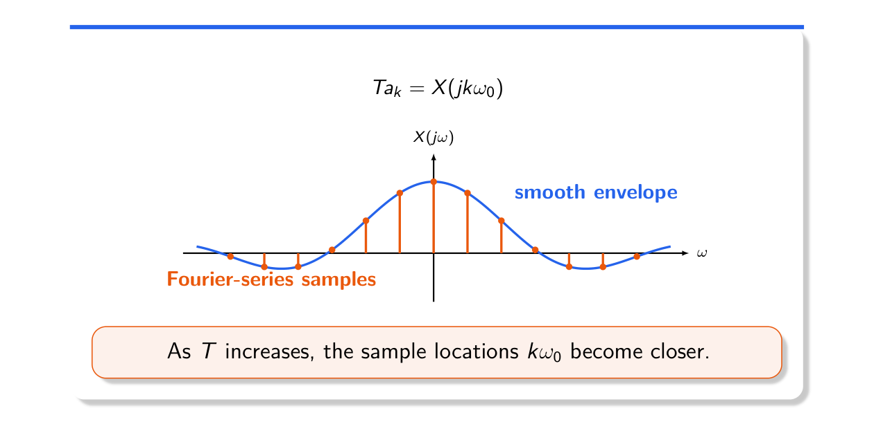
Figure 16.1 — Fourier-series stems are samples of the smooth envelope X(jω) (Lec 7, sl. 12)
Why raw coefficients shrink (sl. 13–14): a_k = (Δω/2π)X(jkω₀) — each stem is the area of a bin of width Δω, so X(jω) is a spectral density. As T grows the lines crowd together and shorten.

Existence and Periodic Signals (textbook)
- Dirichlet conditions for the FT: ∫|x|dt < ∞, finitely many extrema and finite jumps in any finite interval. Sufficient only: cos ω₀t, u(t), δ-trains have transforms containing δ(ω).
- Periodic x with FS a_k: X(jω) = 2π Σ a_k δ(ω − kω₀) (each harmonic e^{jkω₀t} ↔ 2πδ(ω − kω₀)).
- Impulse train Σδ(t − nT) ↔ (2π/T)Σδ(ω − 2πk/T): a train stays a train.

Exam Approach
1. Derivation question: write a_k for the periodic extension, identify T·a_k = X(jkω₀), substitute 1/T = Δω/2π into the synthesis sum, take the limit.
2. Periodic signal: find a_k first, then put 2πa_k impulses at kω₀.
3. State Dirichlet conditions and whether they are necessary.

Practice — Lesson 16
(a) Actual — EEE 211 2021-22 Q5(a). (b) Actual — EEE 211 2023-24 Q6(a). (c) Actual — CSE 311 2021-22 Q1(a), 2017-18 Q1(a). (d) Actual — CSE 311 2020-21 Q3(b), 2019-20 Q1(b), 2014-15 Q6(b).
(a) What happens to x̃(t) = ΣC_n e^{jnω₀t} if the waveform stays the same but T grows? Show that as T → ∞ one period becomes x(t) = (1/2π)∫X(ω)e^{jωt}dω. (18)
(b) x(t) is periodic with impulses +1 at t = 1, 2 and −1 at t = 3, 4 (period 4). Find its FT; plot amplitude and phase spectra. (15)
(c) FT of a gate of width B and the exponential FS of the gate repeated with period 2B; relate them. Spectrum of a pulse vs a pulse train. (20)
(d) Dirichlet conditions — necessary? Represent cos 2πf₀t by an FT. FT of a periodic signal.

✔ Solution
(a) As T increases the lines kω₀ = 2πk/T crowd together and each C_n = (1/T)X(jnω₀) shrinks, but T·C_n stays on the envelope X(jω). Derivation in the grey box above: substitute C_n = (Δω/2π)X(jnω₀) and let Δω → 0.
(b) T = 4, ω₀ = π/2. One period: δ(t−1) + δ(t−2) − δ(t−3) − δ(t−4)
a_k = ¼[e^{−jkπ/2} + e^{−jkπ} − e^{−j3kπ/2} − 1]
even k: a_k = 0; odd k: a_k = ½(−j)^k − ½
a±1 = −½ ∓ j½ (|a| = 0.707, ∠ = ∓135°); a±3 = −½ ± j½ (∠ = ±135°); pattern repeats every 4
X(jω) = 2π Σ_{odd k} a_k δ(ω − kπ/2): impulses of area 2π/√2 = 4.44 at ω = ±π/2, ±3π/2, …

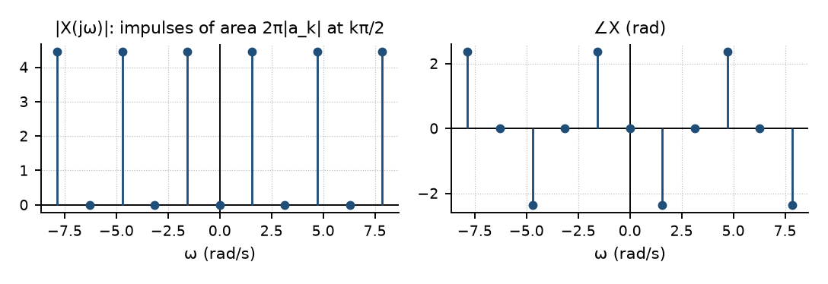
Figure 16.2 — EEE 211 2023-24 Q6(a): amplitude and phase spectra
(c) Gate of width B: X(f) = B·sin(πfB)/(πfB) (continuous). Repeated with period T₀ = 2B: D_n = (1/T₀)X(n/T₀) = ½·sin(nπ/2)/(nπ/2) — lines at n/(2B) Hz whose heights are samples of X(f)/T₀. A single pulse has a continuous spectrum; the train has a line spectrum under the same sinc envelope. Bandwidth (first null) = 1/B Hz in both.
(d) Dirichlet conditions as above — sufficient, not necessary. cos 2πf₀t is not absolutely integrable, yet cos 2πf₀t ↔ ½[δ(f − f₀) + δ(f + f₀)] (sin ↔ (1/2j)[δ(f − f₀) − δ(f + f₀)]). Periodic signals: X = 2πΣa_kδ(ω − kω₀).

Lesson 17 — Rectangles, Shifts and Modulation
Slides 19–44 (Lec 7)

1. Frequency Shift and Modulation (sl. 19–28)
x(t)e^{jω₀t} ↔ X(j(ω − ω₀))
x(t)cos ω₀t ↔ ½X(j(ω − ω₀)) + ½X(j(ω + ω₀))
Each component e^{jωt} times e^{jω₀t} becomes e^{j(ω+ω₀)t}: the whole spectrum slides right by ω₀. A cosine is two rotating exponentials, so it creates two half-height copies at ±ω₀ (damped pendulum, ringing circuits, AM radio).
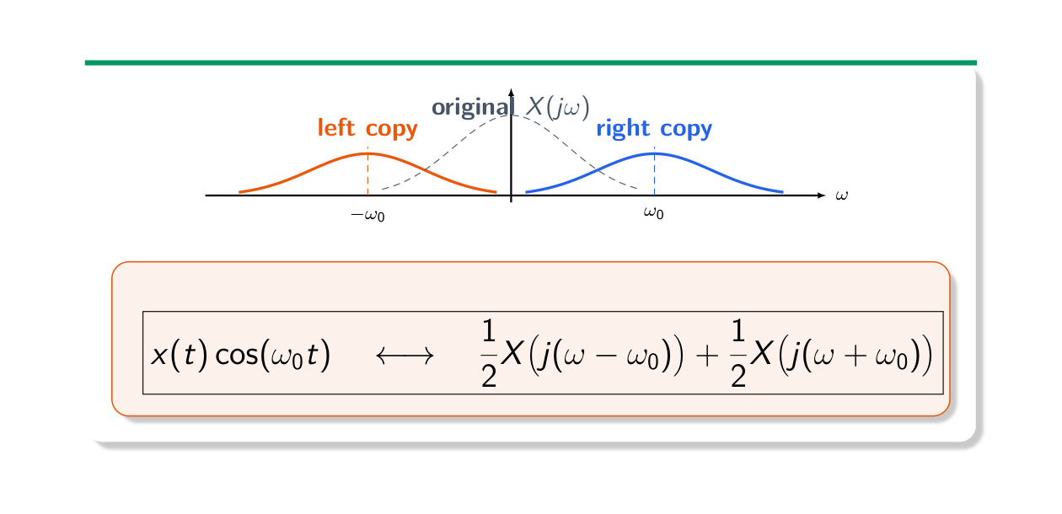
Figure 17.1 — Cosine modulation creates two spectral copies (Lec 7, sl. 27)

2. The Rectangle (sl. 29–38)
x(t) = 1 for |t| < T/2 ↔ X(jω) = 2 sin(ωT/2)/ω (= T at ω = 0)
Wider rectangle → narrower main lobe (first zero at 2π/T). Widths 2 and 6: 2sin ω/ω and 2sin 3ω/ω. Shifted rectangle 4 < t < 10 = width-6 rectangle shifted by 7: X = e^{−j7ω}·2 sin 3ω/ω, X(0) = 6.
Time shift: x(t − t₀) ↔ e^{−jωt₀}X(jω) (|X| unchanged, phase −ωt₀: linear in ω)
Lego block (sl. 36–38): height-1 block on (1,4) + height-0.5 block on (2,3), both centred at 2.5
X(jω) = e^{−j2.5ω}[2 sin(1.5ω)/ω + sin(0.5ω)/ω]
Windowed cosine r(t)cos ω₀t (sl. 39–40): ½[R(j(ω − ω₀)) + R(j(ω + ω₀))] — two sincs centred at ±ω₀
Impulse (sl. 41–44): δ(t) ↔ 1 (flat — a spike needs all frequencies); δ(t − t₀) ↔ e^{−jωt₀}

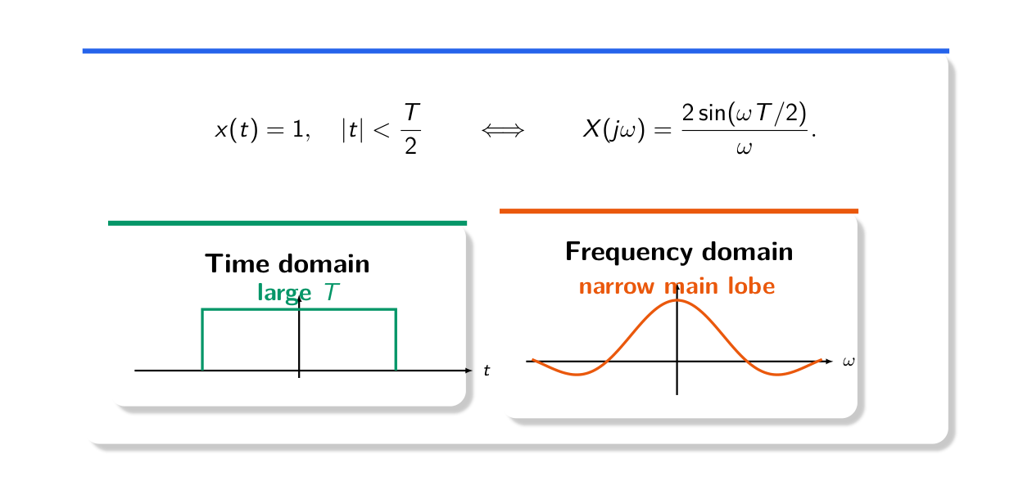
Figure 17.2 — Wider rectangle, narrower spectrum (Lec 7, sl. 31)
MEMORIZE Proof of time shift: ∫x(t − t₀)e^{−jωt}dt, put τ = t − t₀ ⇒ e^{−jωt₀}∫x(τ)e^{−jωτ}dτ. Proof of frequency shift: ∫x e^{jω₀t}e^{−jωt}dt = ∫x e^{−j(ω−ω₀)t}dt = X(j(ω − ω₀)). In Hz: Π(t/τ) ↔ τ sinc(fτ) with sinc(x) = sin(πx)/(πx); g(t − t₀) ↔ G(f)e^{−j2πft₀}.

Exam Approach
1. Decompose the signal into rectangles/triangles/known pulses.
2. Transform each centred piece, then multiply by e^{−jωt_c} for its centre.
3. Modulation: write ½ copies at ±ω₀; sketch both copies with half height.
4. Name every property used.

Practice — Lesson 17
(a) Actual — CSE 219 2023-24 Q1(c). (b) Actual — CSE 311 2019-20 Q2(a), 2012-13 Q6(b). (c) Actual — EEE 211 2023-24 Q5(a). (d) Actual — EEE 211 2022-23 Q2(b), Q4(a). (e) Actual — EEE 211 2021-22 Q6(a). (f) Practice set 7.1–7.4; CSE 311 2014-15 Q5(c), 2012-13 Q5(c), 2018-19 Q4(a), 2011-12 Q5(a), 2022-23 Q1(b).
(a) FT of x₁ = rect(t); then x₂ = rect((t − τ)/T)·cos 2πf₀t by properties. (15)
(b) Show that a time delay causes a linear phase shift. What would happen to a voice signal if this did not hold? (24)
(c) Quadrature multiplexing: u₁ = x₁cos ω_ct, u₂ = x₂ sin ω_ct, r = u₁ + u₂; receiver multiplies by cos ω_ct and sin ω_ct and filters with H(jω). X₁ = rect of height 1 on |ω| < ω_m, X₂ = triangle peak 1, ω_c = 4ω_m. (i) Design H so that y₁ = x₁, y₂ = x₂. (ii) Spectra of u₁, u₂, v₁, v₂, y₂. (20)
(d) (i) m(t) (triangle spectrum, height A, edge ω_m) is down-sampled by 2 (x(t) = m(2t)), multiplied by cos ω₀t and filtered by H_f = B on ω₀ < |ω| < ω₀ + ω_f, with ω_m = ω_f = ω₀/2. Spectra of x, y, z; energy of z. (25) (ii) AM: x cos ω_ct, receiver oscillator cos(ω_ct − θ), LPF gain 2: output? (15)
(e) x_a: triangles of height 1 centred at ±10 (width ±2). x₁ = x_a cos 10t → h₁ = sin 2t/(πt) → x₂ → × p(t) = Σδ(t − 2πn/5) → x₃ → h₂ = 2 sin(2t)cos(10t)/(πt) → x₄. Sketch the spectra. (20)
(f) Shifted rect, Lego block, r(t)cos 3t, impulses; sin²(2πf₀t)g(t); Π(t/τ).

✔ Solution
(a) rect(t) ↔ sin(πf)/(πf) = sinc f (2 sin(ω/2)/ω in ω)
time scaling: rect(t/T) ↔ T sinc(fT); time shift by τ: ↔ T sinc(fT)e^{−j2πfτ}
modulation by cos 2πf₀t:
X₂(f) = (T/2)[sinc((f − f₀)T)e^{−j2π(f−f₀)τ} + sinc((f + f₀)T)e^{−j2π(f+f₀)τ}]

(b) Proof: as in the MEMORIZE box, x(t − t₀) ↔ X(ω)e^{−jωt₀}: magnitude unchanged, phase −ωt₀ — a straight line through the origin with slope −t₀. Meaning: every component is delayed by the same t₀ (group delay −dφ/dω = t₀), so the waveform keeps its shape. A voice signal is a sum of many frequencies; if the phase were not linear, different frequencies would arrive with different delays (dispersion): syllables smear, transients spread, speech sounds distorted even though every amplitude is intact.
(c) v₁ = r cos ω_ct = x₁cos²ω_ct + x₂ sin ω_ct cos ω_ct = ½x₁ + ½x₁cos 2ω_ct + ½x₂ sin 2ω_ct
v₂ = r sin ω_ct = ½x₂ − ½x₂cos 2ω_ct + ½x₁ sin 2ω_ct
(i) H(jω) = 2 for |ω| < ω_f, 0 otherwise, with ω_m ≤ ω_f ≤ 2ω_c − ω_m = 7ω_m (ideal LPF, gain 2)
(ii) |U₁| = ½ rect around ±4ω_m (width ±ω_m); |U₂| = ½ triangles at ±4ω_m;
|V₁|: ½X₁ at baseband + copies of height ¼ (x₁ and x₂ parts) around ±8ω_m; same for V₂ with x₂ at baseband;
|Y₂| = triangle of height 1 on |ω| < ω_m (= X₂)

(d)(i) X(ω) = ½M(ω/2): triangle of height A/2 reaching ±2ω_m = ±ω₀
Y(ω) = ½X(ω − ω₀) + ½X(ω + ω₀): triangles of height A/4 centred at ±ω₀ spanning 0…2ω₀
Z(ω) = B·Y on ω₀ < |ω| < 1.5ω₀: the upper half-triangle from A/4 (at ω₀) down to A/8 (at 1.5ω₀) — an SSB-like signal
E_z = (1/2π)·2∫_{ω₀}^{1.5ω₀} (AB/4)²(1 − (ω − ω₀)/ω₀)² dω = (A²B²ω₀/16π)(7/24) = 7A²B²ω₀/(384π)
(ii) x cos ω_ct · cos(ω_ct − θ) = ½x[cos θ + cos(2ω_ct − θ)]; LPF (gain 2) removes the 2ω_c term:
y(t) = x(t) cos θ (θ = 90° gives zero output — the quadrature null)

(e) X₁ = ½X_a(ω − 10) + ½X_a(ω + 10): a triangle of height 1 at 0 (two halves add) + height-½ triangles at ±20
h₁ = sin 2t/(πt) ↔ ideal LPF, gain 1, |ω| < 2 ⇒ X₂ = triangle of height 1 on |ω| < 2
p(t): period 2π/5 ⇒ P = 5Σδ(ω − 5k); X₃ = (1/2π)X₂ * P = (5/2π)Σ X₂(ω − 5k) (copies every 5, height 0.796,
no overlap since 5 > 4)
h₂ = 2 sin 2t cos 10t/(πt) ↔ gain 1 on 8 < |ω| < 12 ⇒ keeps the copies at ±10:
X₄ = (5/2π)[triangles at ±10] ⇒ x₄(t) = (5/2π)x_a(t) ≈ 0.796 x_a(t) (the band-pass signal is recovered)

(f) Practice set: x = 1 on (4,10): e^{−j7ω}2 sin3ω/ω, X(0) = 6; Lego with heights 3, 4.5:
e^{−j2.5ω}[6 sin1.5ω/ω + 3 sin0.5ω/ω]; r(t)cos 3t: sin(ω − 3)/(ω − 3) + sin(ω + 3)/(ω + 3);
3δ(t+2) − 2δ(t−1) ↔ 3e^{j2ω} − 2e^{−jω}, X(0) = 1
sin²(2πf₀t)g(t) = ½g − ½g cos 4πf₀t ↔ ½G(f) − ¼[G(f − 2f₀) + G(f + 2f₀)]
Π(t/τ) ↔ τ sinc(πfτ) (Lathi) = τ sin(πfτ)/(πfτ); Π(t/2B) ↔ 2B sin(2πBf)/(2πBf)

Lesson 18 — Transform Pairs and Properties Toolbox
Textbook (Oppenheim & Willsky Tables 4.1–4.2), built on Lec 7
x(t) | X(jω) | x(t) | X(jω)
δ(t) | 1 | 1 | 2πδ(ω)
e^{−at}u(t), a > 0 | 1/(a + jω) | e^{at}u(−t) | 1/(a − jω)
e^{−a|t|} | 2a/(a² + ω²) | te^{−at}u(t) | 1/(a + jω)²
sgn(t) | 2/(jω) | u(t) | πδ(ω) + 1/(jω)
rect: 1 for |t| < T/2 | 2 sin(ωT/2)/ω | sin(Wt)/(πt) | 1 for |ω| < W
triangle 1 − |t|/τ, |t| < τ | τ·[sin(ωτ/2)/(ωτ/2)]² | e^{jω₀t} | 2πδ(ω − ω₀)
cos ω₀t | π[δ(ω − ω₀) + δ(ω + ω₀)] | sin ω₀t | (π/j)[δ(ω − ω₀) − δ(ω + ω₀)]
Σδ(t − nT) | (2π/T)Σδ(ω − 2πk/T) | e^{−at²} | √(π/a) e^{−ω²/4a}

Property | x(t) | X(jω)
Linearity | ax + by | aX + bY
Time shift / frequency shift | x(t − t₀) / x e^{jω₀t} | e^{−jωt₀}X / X(j(ω − ω₀))
Scaling | x(at) | (1/|a|)X(jω/a) (compress in time ⇔ stretch in frequency)
Reversal | x(−t) | X(−jω) (= X* for real x)
Duality | X(jt) | 2πx(−ω)
Differentiation | dx/dt | jωX
Frequency differentiation | −jt x(t) | dX/dω
Integration | ∫_{−∞}^{t}x dτ | X/(jω) + πX(0)δ(ω)
Convolution | x * h | XH
Multiplication | x·y | (1/2π)X * Y
Parseval | ∫|x|²dt | (1/2π)∫|X|²dω (= ∫|X(f)|²df)
Real signal | x real | |X| even, ∠X odd; x even ⇒ X real

MEMORIZE Proofs to know: (i) duality — from x(t) = (1/2π)∫X(jω)e^{jωt}dω, 2πx(−t) = ∫X(jω)e^{−jωt}dω; rename t ↔ ω: 2πx(−ω) = ∫X(jt)e^{−jωt}dt = F{X(jt)}. (ii) convolution — swap the order of integration and use the time shift. (iii) Parseval — ∫x x* dt with x* written as the conjugate inverse transform. (iv) scaling — substitute τ = at (|a| because a < 0 flips the limits). (v) real x: X(−jω) = ∫x e^{jωt} = X*(jω).

Exam Approach
1. Recognise the signal as a known pair ± shift/scale/modulate/differentiate.
2. Write each step with its property name (CSE 219 gives marks for naming).
3. For a ratio X(ω) = N/D: partial fractions in jω, invert term by term.
4. Parseval integrals: identify ∫|X|² as the energy of a known x(t) and integrate in time instead.

Practice — Lesson 18
(a) Actual — CSE 219 2022-23 Q6. (b) Actual — CSE 219 2023-24 Q2. (c) Actual — CSE 219 2022-23 Q5(b). (d) Actual — EEE 211 2023-24 Q6(b)–(c), 2022-23 Q2(a), 2021-22 Q5(b), 2020-21 Q1(a), 2019-20 Q6(b).
(a) f(t) = e^{−at}u(t), a > 0; sign(t) = −1 (t < 0), 1 (t > 0). (a) Define f(−t). (b) FT of f and f(−t). (c) sign(t) in terms of f(t), f(−t). (d) FT of sign(t) by properties (name them). (30)
(b) x₁ = e^{−at}u(t), x₂ = e^{−a|t|}. (a) FT of x₁, then of x₂ (name the properties). (b) Evaluate I(a) = ∫ f²/(a² + (2πf)²)² df using Parseval. (30)
(c) X(jω) = 1 for |ω| < 3π; |X₁(jω)| rises linearly from 0 at ω = 0 to 9π at |ω| = 3π (zero outside), ∠X₁ = π/2 (ω > 0), −π/2 (ω < 0). (i) Define X₁. (ii) x(t). (iii) X₁ via X. (iv) x₁ via x. (v) x₁(t). (20)
(d) FT of sin(at)/(πt) and its energy; FT of u(t) and the integration property; closed-form FT of a ramp-and-hold pulse (0 → 1 on [0,1], 1 on [1,2]); inverse FT of X = 1 on 3 < |ω| < 7 plus 1 more on 4 < |ω| < 6; X = jω/(ω² − 3jω − 2): FT of x′(t)cos t; duality.

✔ Solution
(a)(a) f(−t) = e^{at} for t < 0, 0 for t > 0 (= e^{at}u(−t))
(b) F{f} = ∫₀^∞ e^{−at}e^{−jωt}dt = 1/(a + jω); time reversal: F{f(−t)} = F(−jω) = 1/(a − jω)
(c) sign(t) = lim_{a→0} [f(t) − f(−t)]
(d) linearity + time reversal: F{f(t) − f(−t)} = 1/(a + jω) − 1/(a − jω) = −2jω/(a² + ω²)
a → 0: F{sign(t)} = −2jω/ω² = 2/(jω) (X(0) = 0: sign has zero average)
(b)(a) X₁ = 1/(a + jω); x₂ = x₁(t) + x₁(−t) (linearity + reversal) ⇒ X₂ = 1/(a+jω) + 1/(a−jω) = 2a/(a² + ω²)
(b) Differentiation: dx₂/dt ↔ jω·2a/(a² + ω²) = j2πf·2a/(a² + (2πf)²)
|F{dx₂/dt}|² = 16π²a² f²/(a² + (2πf)²)²
Parseval (in f): ∫|dx₂/dt|²dt = ∫|F|²df. dx₂/dt = −a sgn(t)e^{−a|t|} ⇒ ∫a²e^{−2a|t|}dt = a
⇒ 16π²a²·I(a) = a ⇒ I(a) = 1/(16π²a)

(c)(i) X₁(jω) = 3|ω|e^{jπ sgn ω/2} = 3jω for |ω| < 3π, 0 otherwise
(ii) x(t) = (1/2π)∫_{−3π}^{3π} e^{jωt}dω = sin(3πt)/(πt)
(iii) X₁(jω) = 3jω X(jω)
(iv) differentiation property: x₁(t) = 3 dx/dt
(v) x₁(t) = 3 d/dt[sin 3πt/(πt)] = 3(3πt cos 3πt − sin 3πt)/(πt²)

(d) sin(at)/(πt) ↔ 1 for |ω| < a (duality of the rectangle); E = (1/2π)·2a = a/π
u(t) = ½ + ½sgn(t) ↔ πδ(ω) + 1/(jω); ∫_{−∞}^{t}x = x * u ↔ X(jω)[πδ(ω) + 1/(jω)] = X/(jω) + πX(0)δ(ω)
ramp-and-hold: x′ = u(t) − u(t−1) − δ(t−2) ⇒ jωX = (1 − e^{−jω})/(jω) − e^{−j2ω}
X(ω) = (e^{−jω} − 1)/ω² + j e^{−j2ω}/ω
band rects: a rect on a < |ω| < b ↔ [sin bt − sin at]/(πt) ⇒ x(t) = [sin 7t − sin 3t + sin 6t − sin 4t]/(πt)
x′(t)cos t: x′ ↔ G = jωX = −ω²/(ω² − 3jω − 2) ⇒ F{x′cos t} = ½G(ω − 1) + ½G(ω + 1)
duality: proof in the MEMORIZE box (EEE 2019-20 Q6(b), 20 marks — add the example rect ↔ sinc ⇒ sinc ↔ 2π rect)

Older quick answers: −90° phase shifter H = −j sgn ω ⇒ h = 1/(πt), cos ω₀t → sin ω₀t;
sin t·sin(t/2)/(πt²) = π·[sin t/(πt)]·[sin(t/2)/(πt)] ↔ ½·(rect|ω|<1 * rect|ω|<½): |X| = ½ for |ω| < ½,
falling linearly to 0 at |ω| = 3/2; α rect(αt/τ) ↔ τ·sin(ωτ/2α)/(ωτ/2α): α → ∞ gives τ (flat; τδ(t)),
α → 0 shrinks the spectrum onto ω = 0; energy of sin(20π(t − 1/40))/(π(t − 1/40))·cos 30πt = 10
(rect of height 1 on |ω| < 20π, shifted to ±30π with height ½: (1/2π)·2·¼·40π)

Lesson 19 — LTI Systems in Frequency: Filters, Distortionless, Bandwidth
Slides 45–59 (Lec 7: applications) · frequency response, filters, distortionless, PSD: textbook
Applications on the slides: audio and image denoising (remove noise frequencies), JPEG (drop small high-frequency coefficients), MRI (data measured in k-space = frequency domain), music fingerprinting (peak patterns in a spectrogram), vibration diagnosis (faults change the spectrum), ECG (notch out 50 Hz mains hum).
y = x * h ⇔ Y(jω) = H(jω)X(jω) e^{jωt} → H(jω)e^{jωt}

Distortionless Transmission (textbook)
Distortionless: y(t) = K x(t − t_d) ⇒ H(jω) = K e^{−jωt_d}: |H| = K constant and phase −ωt_d linear through the origin (constant group delay t_d). An all-pass system has |H| constant but its phase need not be linear, so it is distortionless only if its phase is linear — otherwise it causes phase (delay) distortion.
RC low-pass H = 1/(1 + jωRC): for ωRC ≪ 1, |H| ≈ 1 and ∠H ≈ −ωRC — approximately distortionless (delay RC) for signals whose bandwidth B ≪ 1/(2πRC).

Ideal Filters (textbook)
Ideal LPF H = 1 (|ω| < ω_c), linear phase e^{−jωt_d}: h(t) = sin(ω_c(t − t_d))/(π(t − t_d))
h ≠ 0 for t < 0 for every finite t_d ⇒ non-causal ⇒ physically unrealizable (Paley–Wiener: |H| cannot be
zero over a band). Practical filters approximate it with a large delay and a truncated sinc.
Ideal band-stop (stop 10 < |ω| < 20): h = δ(t) − [sin 20t − sin 10t]/(πt)
Echo filter H = (1 + k cos 2πfT)e^{−j2πft_d} = e^{−j2πft_d}[1 + (k/2)(e^{j2πfT} + e^{−j2πfT})]
⇒ y = g(t − t_d) + (k/2)[g(t − t_d + T) + g(t − t_d − T)] (a band-limited input inside |f| < B)

Bandwidth, Duration, PSD (textbook)
- Bandwidth = range of frequencies holding (most of) the energy: first-null, 3-dB (|X|² falls to half) or essential bandwidth. δ(t) has infinite bandwidth (flat spectrum).
- Scaling: x(at), a > 1, is shorter ⇒ wider spectrum (time–bandwidth product constant). A derivative boosts high frequencies (|jωX|) ⇒ larger bandwidth. Smoother signals (rect → triangle) have narrower bandwidth.
- PSD of a power signal: S(ω) = lim |X_T(ω)|²/T; P = (1/2π)∫S dω. Periodic x: S = 2πΣ|a_k|²δ(ω − kω₀).
- Empirical H: drive with sinusoids e^{jωt} (or an impulse/white noise), measure output amplitude ratio and phase shift at each ω.

Practice — Lesson 19
(a) Actual — CSE 311 2022-23 Q2(b), 2021-22 Q2(a), 2020-21 Q4(a), 2018-19 Q1(b), 2012-13 Q7(a). (b) Actual — CSE 311 2016-17 Q1(d), 2017-18 Q1(c), 2010-11 Q6(a). (c) Actual — EEE 211 2020-21 Q2(c). (d) Actual — EEE 211 2021-22 Q6(b), 2020-21 Q2(a)–(b), 2019-20 Q6(a); CSE 311 2021-22 Q3(a), 6(a). (e) Older: echo filter, bandwidth questions, RC, band-stop, e^{−αt}u through sin2t/(πt).
(a) Characterize a distortionless system; is an all-pass system distortionless? Physical interpretation.
(b) Ideal LPF: transfer function → impulse response; prove it is unrealizable.
(c) Causal y″ + 6y′ + 8y = 2x: H(ω); response to x = te^{−2t}u(t). (20)
(d) h = e^{2t}u(−t): 3-dB bandwidth, 1/e duration, product; PSD of Σδ(t − nT); 3-dB bandwidth of e^{−3t}u(t); 1/e durations of Ae^{−t/T}u(t), x₁(3t), x₁(t/2); time compression ↔ frequency expansion.
(e) Older (see solutions).

✔ Solution
(a) y = Kx(t − t_d) for every input ⇒ Y = Ke^{−jωt_d}X ⇒ H = Ke^{−jωt_d}: constant gain (no amplitude distortion) and phase linear in ω through the origin (every component delayed by the same t_d, no phase distortion). An all-pass filter only guarantees constant |H|; e.g. H = (a − jω)/(a + jω) has phase −2tan⁻¹(ω/a), not linear ⇒ frequencies are delayed differently ⇒ not distortionless (unless the phase is linear over the signal band, where it then behaves as a pure delay).
(b) H = e^{−jωt_d} for |ω| < ω_c ⇒ h(t) = (1/2π)∫_{−ω_c}^{ω_c}e^{jω(t−t_d)}dω = sin ω_c(t − t_d)/(π(t − t_d)). The sinc extends to t → −∞, so h(t) ≠ 0 for t < 0: the filter responds before the impulse arrives ⇒ non-causal ⇒ not realizable. A pulse input gives an output with ripples (Gibbs) and a non-zero response before the pulse.
(c) H(ω) = 2/((jω)² + 6jω + 8) = 2/((jω + 2)(jω + 4)); X = 1/(jω + 2)²
Y = 2/((jω + 2)³(jω + 4)) = −¼/(jω+4) + ¼/(jω+2) − ½/(jω+2)² + 1/(jω+2)³
y(t) = [−¼e^{−4t} + ¼e^{−2t} − ½te^{−2t} + ½t²e^{−2t}] u(t)
(d) H = 1/(2 − jω): |H|² = 1/(4 + ω²) halves at ω = 2 ⇒ 3-dB bandwidth 2 rad/s; h(0) = 1 falls to 1/e at
t = −½ ⇒ duration ½; product = 1 (fixed for this shape: the time–bandwidth relation)
PSD of Σδ(t − nT): S(ω) = (2π/T²)Σδ(ω − 2πk/T) (power 1/T² in each line)
e^{−3t}u: |X|² = 1/(9 + ω²) ⇒ 3 rad/s (0.477 Hz); durations: T, T/3, 2T (compress ×3 ⇒ duration ÷3,
bandwidth ×3); g(at) ↔ (1/|a|)G(f/a): compression in time = expansion in frequency

(e) x = e^{−αt}u through sin 2t/(πt) (ideal LPF |ω| < 2): Y = 1/(α + jω), |ω| < 2;
E_y = (1/π)(1/α)tan⁻¹(2/α); half of E_x = 1/(2α) ⇒ tan⁻¹(2/α) = π/4 ⇒ α = 2
x = [(1/12)e^{−t/4} + (1/6)e^{−t/2}]u, h = e^{−t/3}u ⇒ y = (e^{−t/4} − e^{−t/2})u(t)
RC, x = Vu: y = V(1 − e^{−t/RC})u(t); band-stop: h = δ(t) − [sin20t − sin10t]/(πt)
bandwidth of δ: ∞; f vs f′: f′ has larger bandwidth (|ωF| grows); g vs g(at), a > 1: g(at) wider

Quick Notes — Fourier Transform
Revision points for Lessons 16–19.

L16 · FS → FT
- T·a_k = X(jkω₀); X = ∫x e^{−jωt}; x = (1/2π)∫X e^{jωt}.
- Periodic: X = 2πΣa_kδ(ω − kω₀). Dirichlet sufficient, not necessary.

L17 · Shifts
- x(t − t₀) ↔ e^{−jωt₀}X; x e^{jω₀t} ↔ X(ω − ω₀); x cos ω₀t ↔ ½[X(ω − ω₀) + X(ω + ω₀)].
- rect width T ↔ 2sin(ωT/2)/ω; δ ↔ 1; (4,10) rect ↔ e^{−j7ω}2 sin3ω/ω.

L18 · Toolbox
- e^{−at}u ↔ 1/(a + jω); e^{−a|t|} ↔ 2a/(a² + ω²); sgn ↔ 2/(jω); u ↔ πδ + 1/(jω).
- Duality X(jt) ↔ 2πx(−ω); d/dt ↔ jω; ∫ ↔ X/(jω) + πX(0)δ; Parseval E = (1/2π)∫|X|².
- CSE 219 2023-24 Q2(b): I(a) = 1/(16π²a).

L19 · Filters
- Distortionless H = Ke^{−jωt_d}; all-pass ≠ distortionless unless phase linear.
- Ideal LPF h = sin ω_c(t − t_d)/(π(t − t_d)) — non-causal.
- 3-dB bandwidth of e^{−at}u: a rad/s. Compress in time ⇔ expand in frequency.

Key Diagrams to Reproduce
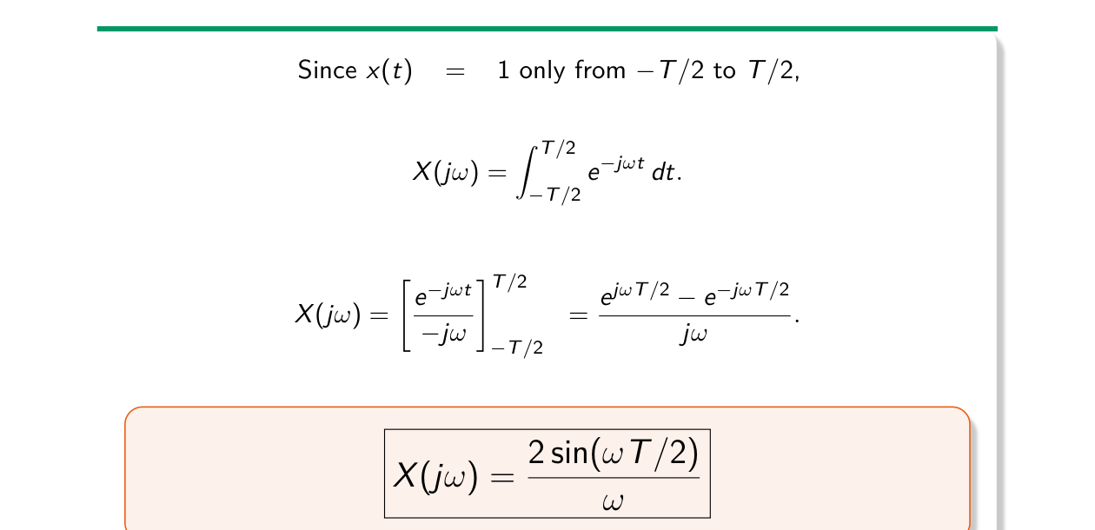
Fourier transform of the rectangle (Lec 7, sl. 30)
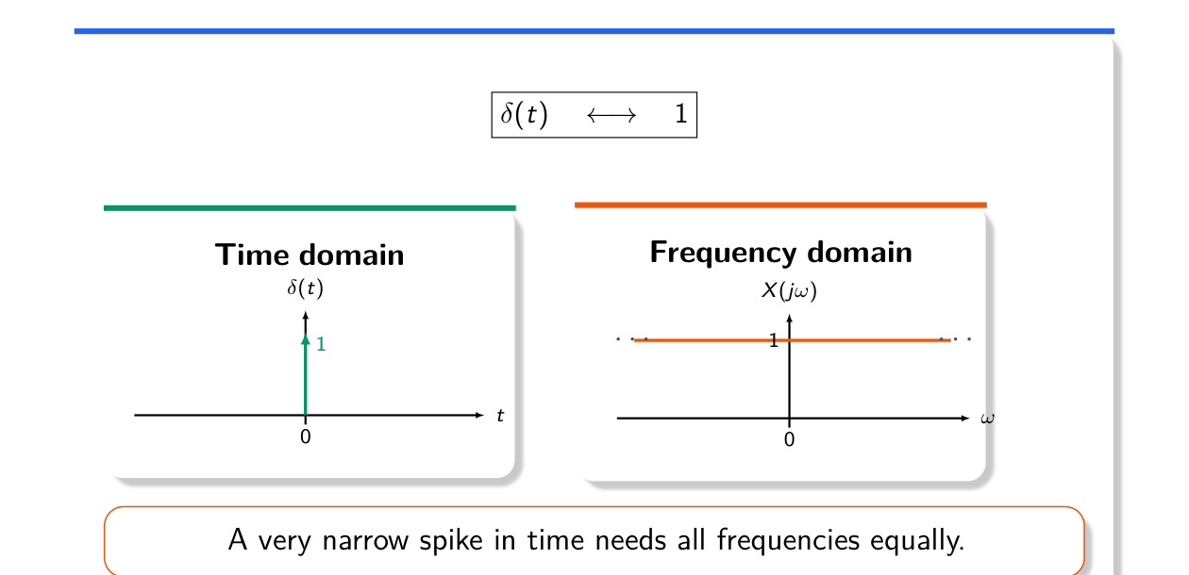
δ(t) ↔ 1 (Lec 7, sl. 43)

